La nourriture!

Nom: __________________

Classe: ____________

Date: _____________
(Food!)

Match the words and pictures

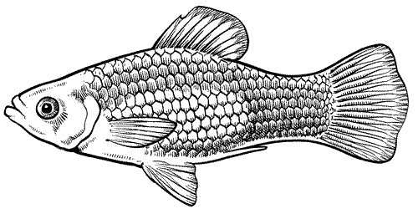
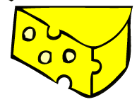
some bread

some cheese

some fish

some green salad

some jam

some steak

some peas
du poisson
du fromage
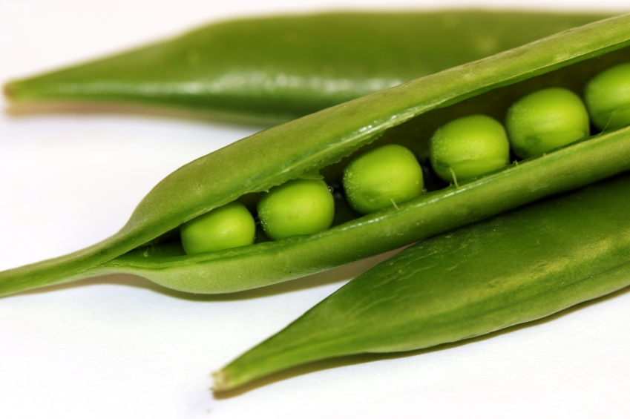
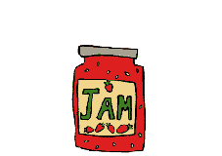

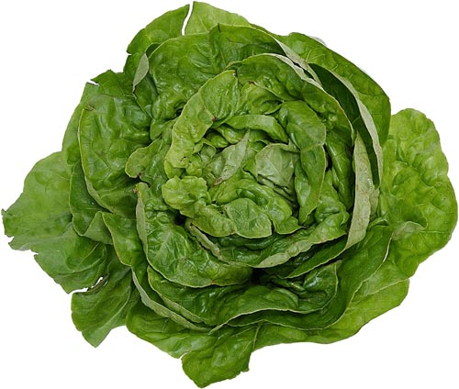
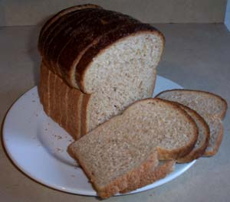
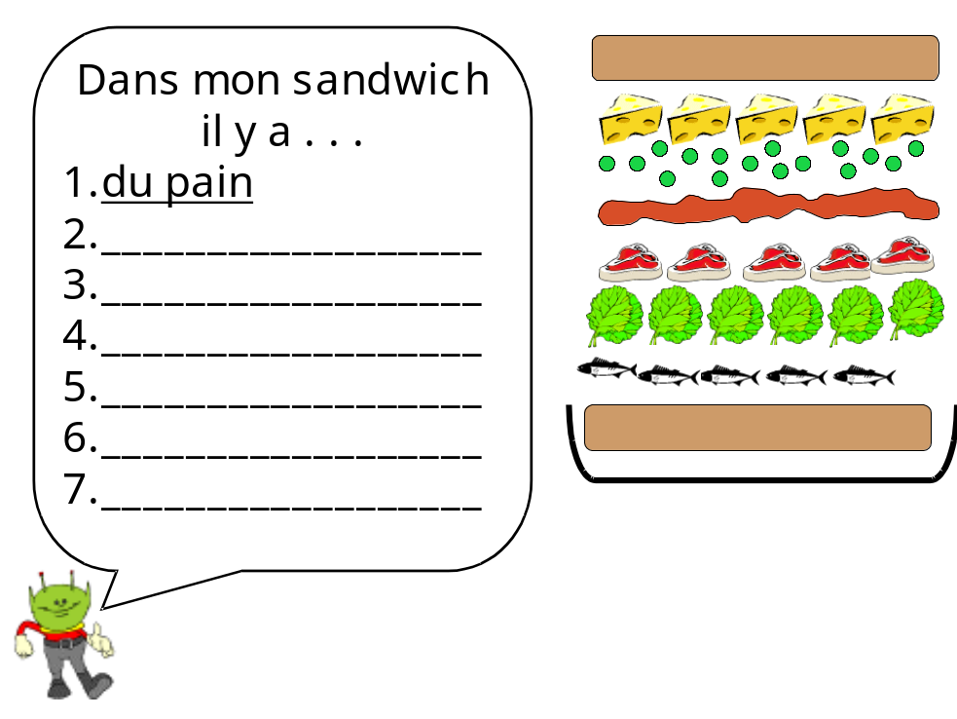
Mon sandwich!
Using the words and pictures to help you, complete the list to show what is in Ali the Alien’s sandwich.

Now design your own crazy sandwich!
des petits-pois
de la confiture
du bifteck
de la laitue
du pain

