March 2020
Hi everyone,
Hope you are all well. I’m still on sick-leave but very conscious that my class may be eager for some planned school work. I am happy to help where possible but it might take me a little longer at times.

To Parents / Guardians:
I’m sure you’ve had enough advice from all sides. These are unusual circumstances and some of you may be working from home and feel that you are expected to keep on top of your children’s education at the same time. There aren’t enough hours in the day. Go easy on yourselves. Where possible, in class, a lot of our learning is developed through play or linking subjects with Science / construction / art / music. There is more than one way to skin a cat.
If your child / children aren’t engaging in a set lesson, don’t worry. A nature walk / scavenger hunt outside may be far more productive and enjoyable for everyone involved. Some of my best childhood memories are from playing in the fields and my dad pointing out birds / trees / wildlife. There is so much to learn in our immediate environment and learning does not necessarily need to be quantified by worksheets and books.
I have attached suggested websites and activities for each subject area. I’m aware that some of you may not have the option of printing at home. Choose what suits your home environment. Answers to activity sheets could also be written into a copy/page if you so wish.

To my students:
Hello! I hope you are well. I miss you all a lot and I hope you are all ok. I know you might be worried at this time but just remember to follow guidelines. This will pass; it will just take a bit of time. I have attached websites/apps and activities for you to do at home. You do not have to complete them all. Choose the activities that suit you, only. The most important job at this time is to remember that these are very unusual times for your parents/guardians too. Ask them every day is there anything you can do to help them. You are all old enough to help with some jobs in the house. It is up to your parents to decide which jobs will suit you.
RTE have introduced from today 30/3/20, a Home School Hub with classes starting from 11am to 12pm. Go to www.rte.ie/learn.
For more ideas/websites to support everyday learning please scroll to the bottom of this document.
I know you are tired of hearing this, but make sure you wash your hands and take care of yourselves and those around you.
Sending you a big virtual hug!
Ms Daly ☺

English
Reading
The best thing to do at home is read. Parents can read with children as well as children spending some time to read on their own.
If you are baking/cooking together at home, ask the children (where possible) to read the ingredients and instructions. This is an excellent English lesson and they won’t realise they’ve been tricked into reading ☺
They can also retrieve the items necessary.
Storyjumper is an excellent website for creating stories/online books. Children can choose backgrounds, characters and text. When their story is complete they can also add in their own narration by recording their own voice to read the story. Room 4 love this website and this year we created a Superman tour book. When the class were in Room 1 we created an Emperor penguin book and one based on a poem they had studied.
https://www.storyjumper.com/book/read/49247386/5e8212cac1fb6 This is the link to the Emperor Penguin book created when this year’s class were in Room 1. Your son/daughter can talk you through how it was made if they wish. It can be a bit tricky to use and requires a bit of patience. It is a suggestion only. They may also be able to create a book with their siblings so it could become a group project.

https://stories.audible.com/start-listen Audible is free due to schools being closed. Children can stream an incredible collection of stories. All stories are free to stream on your desktop, laptop, phone or tablet.

Spelling
Children can use www.spellingtraining.com. The class loved the activities associated with this website. They may choose spellings from their Spell Well books. Alternatively they could choose topic words, e. g. Easter vocabulary, King John’s castle vocabulary

Writing
This can be linked with other lessons/activities e. g. creating scavenger hunt lists. See below under SESE.

Twinkl has seemingly endless resources. I thought I would be able to attach activity sheets here but they are encrypted unfortunately. Feel free to go to the website (listed below) and enter your required topic, e. g. Easter / Easter Maths activity book. You will require a printer for most activities, however, although they do have access to some books made by the Twinkl website.
I’ve since discovered that some teachers attached Twinkl PDF to their emails. I will attach these and hopefully you will be able to access them. If not, please go to the website as indicated above.

Recommended websites
https://stories.audible.com/start-listen
www.starfall.com Reading, phonic and Maths activities
www.twinkl.ie Lots of free resources and activity sheets
www.spellingtraining.com
www.storyjumper.com

Maths
Besides children’s textbooks and activity sheets, there are a lot of environmental Maths activities that children can engage in, both indoors and outdoors.
For example, when emptying the dishwasher, they could count:
How many dinner plates?
How many side plates?
How many more dinner plates than side plates?.....etc
Tasks like tidying shoes encourages children to count in 2s
You can find other activities both indoors and outdoors that encourage them to also count in 3s, 5s, 10s etc...
If you have outdoor chalk you could draw hopscotch on the path outside to encourage counting. You could choose to draw the numbers in 2s for example if that suits your lesson on a given day.
Hopscotch could also be drawn vertically on a wall and children encouraged to kick a ball at number 1, then number 2 and so on...If you do not have chalk you could create this using masking tape and make the number boxes on the wall.
Obstacle courses - Most phones have a stopwatch function so children can time each other using obstacle course as an alternative to racing each other or just compete against themselves and try to improve on their time. (link to PE)

Recommended websites
www.starfall.com
www.topmarks.co.uk
www.coolmath.com
www.twinkl.com

SESE
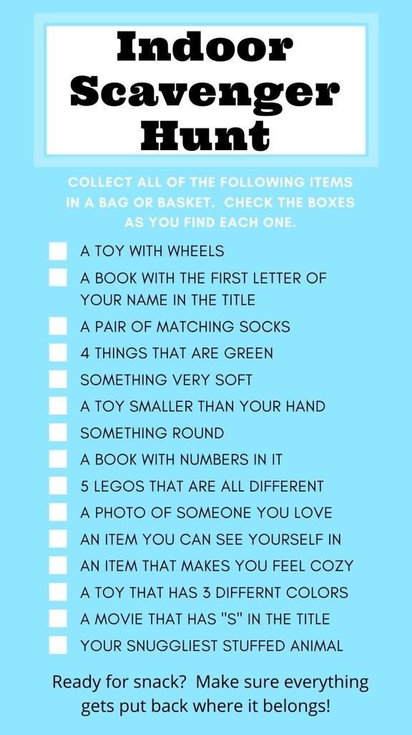
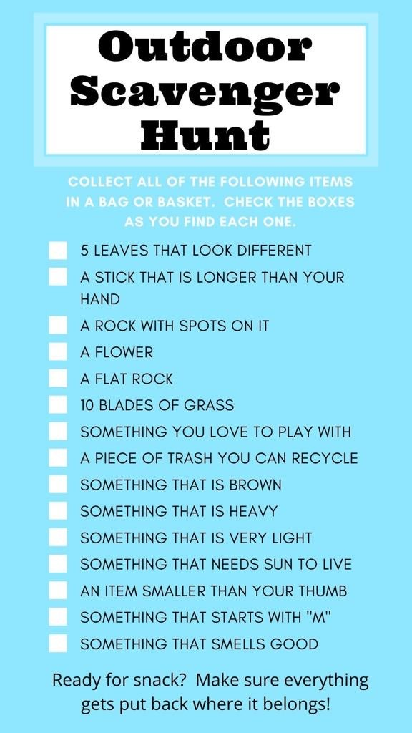
These are ideas above for indoor and outdoor scavenger hunts. Feel free to create your own. Children often have much better ideas than us! Creating a list encourages them to write too. They could also draw their scavenger hunts if they prefer.
Easter egg hunt: Draw map of house and/or garden as part of Easter egg hunt. Children could include directions where possible.
www.anpostschoolbag.ie has a lot of resources for primary school students, including resources for History, Geography, Role play, Maths, English, Drama and Art.
www.online.seterra.com Geography map quiz site. Quizzes available about
- Countries
- Capitals
- Flags
- Oceans
- Lakes
You can scroll to section specific to Ireland if you choose.
www.littlebinsforlittlehands.com has a lot of STEM ideas, some free activities/printables that you can request to be sent to your email address

Recommended websites
www.anpostschoolbag.ie
www.nationalgeographic.com
www.worldbookonline.ie
www.online.seterra.com

Art
Some children may have LEGO at home or similar building bricks. Please see website below for ideas. If you’re in a position to download apps, the Channel 4 app is free. (This player can be accessed on laptop also)There is a show called Lego Masters UK that can be viewed in the app and cast on to your TV if you have this option. An alternative is to watch on desktop/laptop/phone/tablet. It makes for great family viewing and may inspire some of our creative LEGO builders.
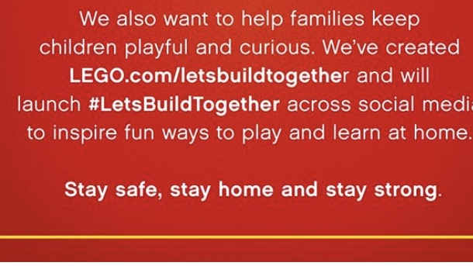
Shadow drawing- can use different objects/ toys.
Could also do a self-portrait shadow drawing.
Potato prints
Symmetry paintings
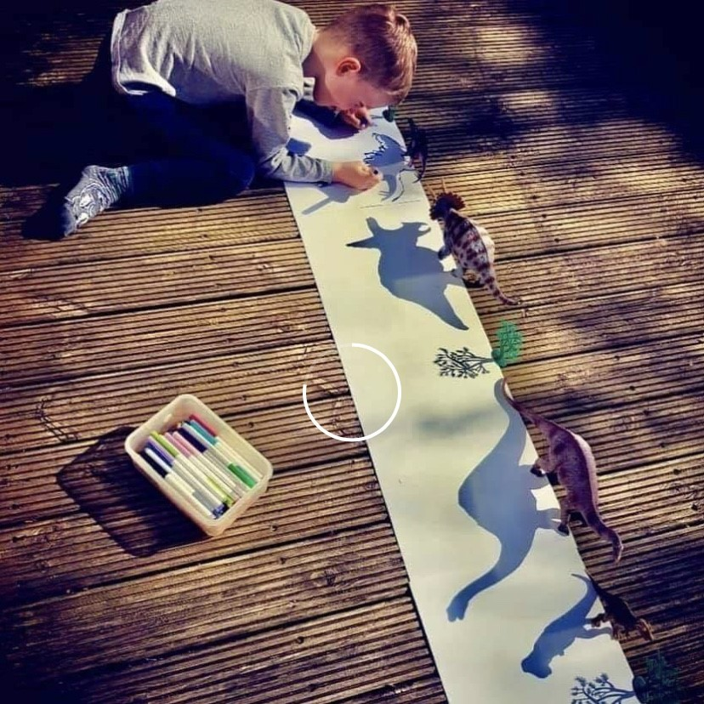
www.decorativeceilingtiles.net has a host of links to art lessons and websites for children.

Music
This is a lovely opportunity to listen to music together at home, even while engaging in other activities, e. g. baking.
This year Room 4 were learning Ireland’s call and The Wild Rover. They have also listened to Oró Sé do bheatha abhaile. Our children do not learn Irish in school, however I feel that it is of benefit to them to be able to recognise some old Irish songs. This, of course, is your own choice and there is no point playing music if they/you do not like it.
Children could make home-made percussion instruments (link with art) using kitchen roll inserts and rice/sunflower seeds etc....
www.incredibox.com Room 4 love this website. It is a beatbox composition site. It has a free demo option on desktop/laptop. If you wish to use the app it has to be purchased. In class we use free version only.
www.sfskids.org This is a great website which allows children to explore the instruments of the orchestra.
www.mydso.com Please go to the Educate section.
www.gonoodle.com

Drama
Any topics you choose to cover at home can be brought to life using Drama, e. g. King John’s castle, children could dress up as soldiers or King John and create an indoor / outdoor castle (fort) and engage in role play. The opportunities are endless. Again the children will often lead imaginative play themselves and may require limited direction only.

PE
- Obstacle course
- Drills weaving around cones (substitute stones/ jumpers/toys?)
- Hopscotch
- Vertical hopscotch (on wall)
- Practise soloing with football/ soccer ball
- Hula hoop
- Hurling target practise
- Stopwatch – time running races
- Run to wall, skip back / jump back / dance back
www.thebodycoach.com - Joe Wicks aka The Body Coach is offering free PE lessons for children at 9am every weekday morning.
www.gonoodle.com – a great resource for songs and dances to keep little ones occupied.

Recommended websites:
www.gonoodle.com
www.thebodycoach.com

SPHE
Personal Hygiene
This is something we always emphasise in Room 4, and at the start of the year there is a month-long focus on the importance of personal hygiene and the importance of washing our hands, especially after using the bathroom. Room 4 chose Baa Baa Black sheep to sing to themselves as they washed their hands to ensure that their hands were washed properly. The importance of this hand hygiene cannot be overemphasised at this time.
https://youtu.be/kiWnA30gLZk This is a link to a Wash your hands song to the tune of Baby Shark. Some students in Room 4 will like this song more than others but as some have younger siblings they may enjoy singing it with them to encourage hand washing.
This time at home can be a perfect opportunity to develop important life skills.
- Tying laces
- Opening / closing buttons
- Opening / closing clasps
- Opening / closing zips
Encourage those who require help getting dressed in the morning / night to further develop their independence skills.
Recommended websites
www.twinkl.ie

Mindfulness
Remember it is so important to look after your mental health and wellbeing. If we are not healthy or feeling good we cannot focus. This really should be number 1 on the list but I wanted to end this note on a positive and pro-active one. The happiness of the children in our care is the most important factor in all of this. They pick up on our stresses. While this isn’t completely unavoidable, reminding them that you are here for them is very important at a time like this. What I have said to my family is that I would be more worried if the government were not taking this seriously. They are taking all precautions and measures necessary and this is of huge comfort to me personally. This is just something to keep in mind.
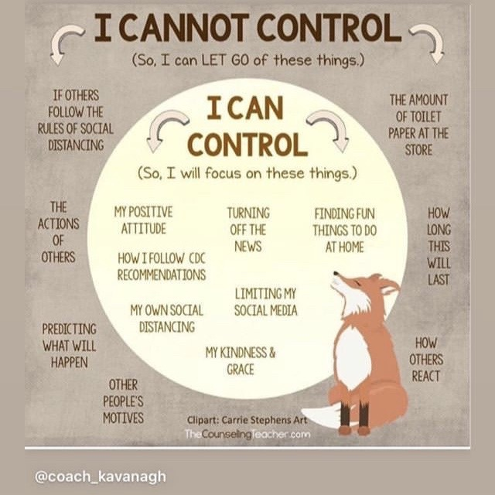
www.rte.ie/brainstorm/2020/0324/1124989-self-isolation-quarantine-coroanvirus This is a good article to support parents/guardians at this time.
https://youtu.be/Bk_qU7l-fcU A 12 minute Mindfulness Meditation for Kids – Breathing Exercise.
A number of book companies/educational websites have removed restrictions on their websites so they can be accessed for free.
www.cjfallon.ie
www.oxfordowl.co.uk
www.twinkl.ie
www.folensonline.ie
www.starfall.com
www.worldbookonline.com
www.nationalgeographic.com
https://stories.audible.com/start-listen
www.kidsactivitiesblog.com – list of education companies offering free subscriptions.



