Homework Sheet
Name:
Think of one project that you have made in the workshop this year.
Did I try my best and work hard to finish my project as well as could have? Colour in the face to tell.
Draw a circle around a tool that you used on the project.
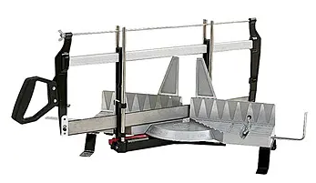 | 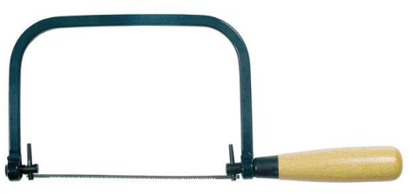 | 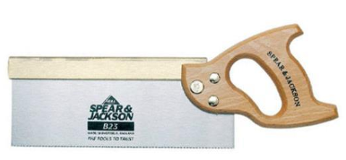
Mitre Saw | Coping Saw | Tenon Saw
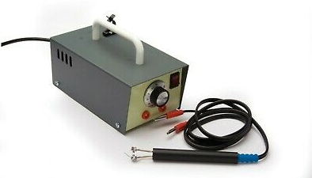 | 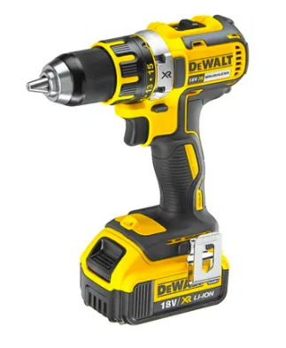 | 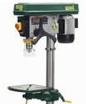
Pyrography Pen | Cordless Drill | Pillar Drill
Write about one thing that you think you did well in the project.
Sketch one of the tools that you used and write its name underneath it.

